Unit 11: BOOKS Period: 74
READING Pre date: Feb 16th

I. Aims: By the end of the lesson, students can:
+ Develop their reading skill
+ Understand how to read books
II. Method and teaching aids:
+ Integrated
+ Books, pictures, posters, charts
III. Procedures:

Stages | Teacher’s activities | Students’ activities
W  A  R  M  E  R  10 mns | - Guessing game  * Ask SS some questions:  1. What is made from wood pulp?  2. Who wrote “Hamlet”?  3. What is the purpose of watching TV?  * Ask SS to find out the key word.  What are these words related to?  The group that finds the key word first is the winner.  - Brainstorming: Ask SS to give out some types of books.  picture books reference books  text books  BOOKS  - Lead to the new lesson: different books are read in different ways.  Today, we’ll study how to read books | Groupwork (2 groups)  Paper  Shakespeare  To relax, to get information,...  Key word: BOOKS  Give some types of books individually as required
P  R  E  -  R  E  A  D  I  N  G  30 ms | - Activity 1: Matching (poster)  Ask SS to repeat the vocabulary after the teacher  - Checking vocabulary  - Activity 2: True/ False Statement Prediction (poster)  - It is impossible to read different types of books in different ways.  - When you “taste” a book you read it carefully from the beginning to the end.  - Books with good stories are often described as “hard-to-put-down”.  - All books are for reading slowly and carefully.  - Television has replaced books altogether. | Work in groups of 4  Answers: 1-g, 2-d  3-a, 4-f  5-c, 6-e  7-b  (Books closed)  Work in 2 groups  Guess whether the statements are T or F
  A | B
  - Swallow  - Dip into  - Taste  - Digest  - Chew  - Hard-to-pick-up again  - Hard-to-put down | a. nếm (đọc thử)  b. không thể đặt xuống  c. nhai (nghiền ngẫm)  d. chấm vào (đọc qua loa)  e. không thể cầm lên lại được  f. tiêu hóa ( đọc và suy ngẫm)  g. nuốt chửng (đọc ngấu nghiến)
W  H  I  L  E  -  R  E  A  D  I  N  G  40 mns | - Activity 1: Read the text  - Activity 2: Checking T/F Statement Prediction  1. F 2. F 3. T 4. F 5. F  - Activity 3: Answer the questions  Ask SS to practice in pairs  Give feedback  - Three  - When I find a good story and have time to enjoy it.  - I read a few pages to see if it’s the one I can easily read and understand.  - Television can bring you all the information and stories with colour pictures and actions.  - Books are still a cheap way to get information and entertainment; you can keep a book forever and read it many times. | Work individually  Read the text silently in 3 minutes  Pair work: One asks and one answers  Work individually
P  O  S  T  -  R  E  A  D  10 mns | - Questions and Answers  Ask SS some questions:  1. What sort of books do you like to read?  2. How do you read books?  3. When do you read books?  Do the exercise in the book (p.121), prepare Speaking lesson for the next period
Unit 11: BOOKS Period: 75
SPEAKING Pre date: Feb 18th

I. Aims: By the end of the lesson, students can: - know how to ask about reading habits
- talk about characters in a book
II. Method and teaching aids:
Method: integrated skill
Teaching aids: textbook, posters, cards...
III. Procedures:

Stages | Teacher’s activities | Students’ activities
W  A  R  M  E  R  5 mns | - Guessing game:  - stick 12 cards on the board with the names of some writers, their works and the characters.  - put students into 3 groups  - ask students to group the writers with their works and the characters.  - the group that has more right answers will be the winner.  Shakespeare  The last leaf  Thuy Kieu  Johnsy and Sue  Mark Twain  Romeo and Juliet  Kieu’s story  Nguyen Du  Romeo and Juliet  Tom Sawyer  The Adventures of Tom Sawyer  O. Henry  → Lead to the new lesson: Today, we’ll practise speaking about books, and the characters in a book. | - work in groups of 6  - go to the board and do as required  → Answer:  
  The author | The work | The main  character
  Nguyen Du  .  .  . | Kieu’s story  .  .  . | Thuy Kieu  .  .  .
P  R  E  -  S  P  E  A  K  I  N  G  15 mns | - TASK 1:  - Activity 1:  Multiple choice question  ( poster)  - set students in groups of 4  - give students 6 questions, and then ask them to choose the correct questions to complete the conversation 1:  a. What author do you like best?  b. How do you often read books?  c. What sort of books do you like to read?  d. When do you often buy book?  e. How often do you read books?  f. When do you often read books?  - Activity 2: Practising the conversation:  - ask students to practise the conversation. | - work in groups of 4  - do as required  → Answer:  1 - c  2 - b  3 – f  - work in pairs, do as required
W  H  I  L  E  -  S  P  E  A  K  I  N  G  20mns | - Activity 1: Checking T/F prediction  - Ask Ss to listen to the tape/ the teacher for the first time to check if their prediction is right or wrong.  - Give feedback.  a. F, b. F , c. F , d. T , e. T  - Activity 2: Correcting the sentence  - Ask Ss to work in groups of 4.  - Ask Ss to listen to the tape again to correct the above sentences .  - Give feedback:  a. A Canadian family goes to England and leave their pets with a friend.  b. Though they are well treated, they miss their family.  c. Each animal has a distinct personality.  - Activity 3: Circle the correct answer.( Task 1 in the textbook)  - Ask Ss to work in pairs.  - Ask them to listen to the tape again before doing the task. | Pairwork  -Listen to the tape/ the teacher for the first time.  - Decide the right answers.  - Work in groups of 4.  - Listen to the tape again before correcting the sentence.  - Pairwork.  - Do as required.  - Give out the answer:  1.B 2. C 3.B 4. A 4. A
P  O  S  T  -  S  P  E  A  K  I5mns | - Discussion  Ask Ss to work in groups of 4, discussing the question : “ Would you like to read the book or wouldn’t you? Why/ Why not? | - Discuss the question in groups.
Unit 11: BOOKS Period: 76
LISTENING Pre date: Feb 20th

I. Aims: - Improve Ss’skill of listening for specific information related to a book a person has just read.
II. Method and teaching aids:
- Integrated skill.
- Poster, textbook, cards . . . .
III. Procedures:

Stages | Teacher’s activities | Students’ activities
W  A  R  M  E  R  4 mns | * Guessing Game:  - Stick some cards with the name of some animals on the board.  - Divide the class into two groups.  - Ask Ss to pick out what animals are often raised as pets at home.  - Check Ss’ task and decide which is the winner.  + tiger/ cat/ elephant/ dog/ parrot/ monkey/ snake/ bear/ goat  - Ask Ss some questions to lead to the lesson:  a. Do you have a pet at home?  b. Do you love your pet?  c. Do you think that your pet loves you?  d. Have you ever read any book about pets? What do you think about it?  * Today we will listen to a person presenting a book about pets that he has just read. | * Group-work.  - Give out the answer:  + cat/ dog/ parrot/ monkey/  - Listen to the teacher.  - Answer the teacher’s questions individually.
P  R  E  -  L  I  S  T  E  N  I  N  G  8 mns | 1. Activity 1: Pre-teach vocabulary:  Elicit the word from Ss.  - incredible (synonym)  - survive (translation)  - reunited ( example):  The South and the North of Vietnam were reunited in 1975.  2. Pronunciation: Ask Ss to practise pronouncing the words in the book.  3. Activity 2: T/F Statement Prediction  - Divide the class into 2 groups.  - Use a poster with some statements on it:  a. A Canadian family goes to England and leave their pets with a relative.  b. The pets miss their family because they are not well treated.  c. All the animals have the same personality.  d. The old dog is the most impressive of them.  e. It is interesting for anyone who likes animals to read this book.  - Ask Ss to guess if the sentence is true or false. | - Work individually.  = unbelievable  = sống sót  = đoàn tụ, thống nhất  - Listen to the teacher and practise pronouncing the words chorally and individually.  - Work in groups.  - Guess if the sentence is true or false freely.
W  H  I  L  E  -  L  I  S  T  E  N  I  N  G  25 mns | 1. Activity 1: Checking T/F prediction  - Ask Ss to listen to the tape/ the teacher for the first time to check if their prediction is right or wrong.  - Give feedback.  a. F, b. F , c. F , d. T , e. T  2. Activity 2: Correcting the sentence  - Ask Ss to work in groups of 4.  - Ask Ss to listen to the tape again to correct the above sentences .  - Give feedback:  a. A Canadian family goes to England and leave their pets with a friend.  b. Though they are well treated, they miss their family.  c. Each animal has a distinct personality.  3. Activity 3: Circle the correct answer.( Task 1 in the textbook)  - Ask Ss to work in pairs.  - Ask them to listen to the tape again before doing the task. | Pairwork  -Listen to the tape/ the teacher for the first time.  - Decide the right answers.  - Work in groups of 4.  - Listen to the tape again before correcting the sentence.  - Pairwork.  - Do as required.  - Give out the answer:  1.B 2. C 3.B 4. A 4. A
P  O  S  T  -  L  I  S  T  E  N  I  N  G  8 mns | - Discussion  Ask Ss to work in groups of 4, discussing the question: “ Would you like to read the book or wouldn’t you? Why/ Why not? | - Discuss the question in groups.

Unit 11: BOOKS Period: 77
WRITING Pre date: Feb 20th

I. Aims: By the end of the lesson, Ss can know how to write a book report.
II. Methods and Teaching aids:
- Integrated skill.
- Posters, textbook, sub-board,. ...
III. Procedure:

Stages | Teacher’s activities | Students’ activities
W  A  R  M  E  R  3mns | - Brainstorming  - Divide the class into two groups.  - Ask Ss to fill in the chart about talking about a book.  Talking about  a book author  - The group that has more right answers will be the winner.  - Leading to the lesson:  When you talk or write about a book, you often have to mention these things in certain orders. Today, you will learn how to write a book report. | - Work in groups.  - Ss from the two groups go to the board and write down the answers.  Eg: author; character; topic; title; story; etc
P  R  E  -  W  R  I  T  I  N  G  12mns | - Task 1:( Reordering)  - Ask Ss to work in pairs, read and put the questions under the correct headings.  - Go around helping Ss when they have difficulty in vocabulary.  - Ask Ss to give out the answer.  - Give feedback. | - Listen to the teacher to gat ready for the new lesson.
W  H  I  L  E  -  W  R  I  T  I  N  G  17mns | - Task 2 ( Controlled-writing)  - Ask Ss to work in groups of 4.  - Ask Ss to ask and answer the above questions about a book they have just read, then take notes the ideas for the report.  - Task 3 (Less-controlled writing)  - Ask Ss to work individually.  - Ask Ss to use what they have just taken notes to write a book report on their sub-boards.  - Go round to help Ss if necessary. | - Work in pairs.  - Do as required.  - Answer:  a. General introduction: 7, 4,9  b. Summary of the book’s content: 2, 5, 6, 8  c. Conclusion: 1, 3  - Work in groups of 4.  - Do as required.  - Take notes the ideas for the report.
P  O  S  T  -  W  R  I  T  I  N  G  13mns | - Giving comment:  - Ask 3 Ss to show their writing in front of the class.  - Ask the rest to give comment on what their friends have read.  - Correction:  - Ask Ss to find out the mistakes in each writing.  - Ask Ss to correct them.  - Give feedback.  - Homework: - Rewrite the book report at home.  - Prepare Language focus for the next class. | - Write the report individually.  - Stick the sub-boards on the board.  - The rest give comment.  - Look at the writing on the board and find out the mistakes.  - Correct the mistakes.

Unit 11: BOOKS Period: 78,79
LANGUAGE FOCUS
I. Aims: By the end of the lesson, Ss will be able to:
- Stress syllables correctly.
- Use modals in passive voice
II. Methods: integrated, mainly communicative
III. Teaching aids: posters, hand-outs, textbook…
IV. Procedure:

Stages | Teacher’s activities | Students’ activities
W  A  R  M  E  R  5mns | - GAME:STRESS MATCHING  - Divide the class into small groups of three or four.  - Give each group the worksheet below.  - Ss work together to decide which sentence or group of words from the box has to go with its symbols (after listening to the teacher/ the tape).  - The first one is done as an example.  Note: O is used for stressed syllable.  Key answer: 1-d; 2-a; 3-e; 4-f; 5-b. | - work in groups of four  - do as required  0-c  1-  2-  3-  4-  5-  -Listen to the teacher and take notes
  A | B B
  0. Black or white? | a. O ● ● O
  1. Why did you behave like that? | b. ● O ● ● ● O ●
  2. Come for a swim. | c. O ● O
  3. I think it will be fine. | d. O ● ● O ● O
  4. She’s gone for a walk in the park. | e. ● O ● ● ● O
  5. I wonder if he’ll ever come back | f. ● O ● ● O ● ● O
7 ms | - PRONUNCIATION:  - English language has stress – time rhythm. That is to say the beats or stress pulses in connected speech follow each other at roughly equal intervals of time.  - This means that stressed syllables will tend to occur at relatively regular intervals whether they are separated by unstressed syllables or not.  Example:  1 2 3 4 5  Walk down the path to the end of the canal.  - In this sentence, the stressed syllables are given numbers:  + Syllables 1 and 2 are not separated by any unstressed syllables, 2 and 3 are separated by one unstressed syllables, 3 and 4 by two and 4 and 5 by three.  - The more unstressed syllables there are more faster a stress, the quicker they must be said in order to  “catch” the next pulse.  Example: Yes, that was probably necessary, John.  - Activity 1: Listen and repeat  - Read aloud the sentences(part 1) and have Ss listen  - Read again and ask Ss to repeat  - Call on some Ss to read and make corrections if necessary.  - Activity 2: Practise reading these sentences  - tell the Ss to give rhythm of the sentences on page 126 by marking the primary stress over the main stress syllables in pairs.  - check the answer with the whole class.  - call on some Ss to read the sentences, paying attention to the stressed syllables.  → Feedback:  - Peter’s coming in a minute if he can.  - Come and see us at our new apartment.  - Where’s your new apartment? Is it in another district?  - Why was he trying to embarrass me?  - Probably he wanted you to notice | - listen to the T and repeat(chorally and individually)  - do as required  ( group work → individually)
PRE  SEN  TA  TI  ON  13mns | - GRAMMAR: Modal in passive voice:  - get Ss to recall the form of modals:  must/ can/ may/ will + be + past participle  Ex: This report must be finished today.  Videos like this one can be bought everywhere. | - do as required  - work in group of 4
P  R  A  T  I  C  E  12mns | - Activity 1:  - call on some Ss to write their answers on the board  - correct the mistakes  → Feedback:  1.This machine mustn’t be used after 5.30 p.m  2. This machine must be cleaned every time it is used  3. The flowers should be kept in a warm sunny place.  4. Your bill should be paid before you leave the hotel.  5. The information should be given to us now.  6. Toothpaste can be bought at the drug store.  7. Children should be warned not to speak to strangers  8. The mystery can’t be solved.  9. Travelers’ cheques can be exchanged at most banks.  10. The news shouldn’t be told to her. She might be killed by it.  - Activity 2:  - ask Ss do Exercise 2 on the page 127 ( textbook)  - call on some Ss to write the answers on the board.  - go over the answers with the class.  → Feedback:  1. will be prepared 5. should food be chosen  2. Is food going to be cooked..? 6. have to be offered  3. will be pre – packed 7. could be selected  4. can be warmed 8. ought to be made | - work in pairs  - do as required
PRO  DUC  TION  8ms | - Activity 3:More exercise: Make passive sentences by using the words given:  1. Your father’s advice/ should/ follow.  2. The fire/ could/ cause/ a short circuit.  3. The scientific book/ have to/ return/ to/ the library/ Phong.  4. He/ might/ interview/ the principal.  …………………………………….  T gives the task:  The party is going to be held on next Sunday. What things should be done ? | -work in groups of 4  -answer

The 3rd 45-mimute TEST Period: 80
Unit 12: WATER SPORTS Period: 81,82
READING
I. Aims: By the end of the lesson, students will be able to - Understand the passage about the water polo.
- Guess the meaning in context. - Talk about some sports.
II. Teaching aids: pictures, handouts.
III. Procedures:
Stages | Teacher’s activities | Students’ activities
W  A  R  M  E  R  5 mns | - Guessing game  - T gives pictures of water, water polo players, a goal and a ball in turns  -Teacher raises the question: “Guess what sport game?’’    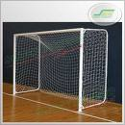  - T asks “What kind of sport game can you guess when seeing these pictures?”  WATER SPORTS  windsurfing  swimming  Rowing  Water polo  diving  T leads to the new lesson | - Guess  swimming  rowing  diving  Football  Water polo  Sts answer  Water polo  Diving  Swimming  Rowing  Windsurfing
P  R  E  -  R  E  A  D  I  N  G  15 mns | - Pre teach vocabulary:  - Vertical post (v) (picture)  - goalie (n) = goal keeper (synonym)  - Sprint for (v) (translation)  - Defensive player (n)(example) Ronaldo was a famous ................. of Manchester United team.  - Penalty (n) (situation) If Cong Vinh uses his hands to catch the ball, what will happen to him?  - opponent (n) a person who tries to defeat another in a competition. (explanation)  - eject (v) put in ( antonym)  - Checking: Rub-out and remember  - True / False statements prediction:  1. ………Water polo is played in sea.  2. ………There are eleven players per team.  3……….The goalie is the person who can hold the ball with both hands  4. ………At least one player must touch the ball after a free throw before a goal can be score. | Realize the words( meaning, pronunciation, stress)  Repeat  Note- take  Ss guess the answer:  - T/F  - T/F  - T/F  - T/F
W  H  I  L  E  -  R  E  A  D  I  N  G  20mns | - Checking T/ F statements:  - T lets sts read the text and check up the T/F statements.  - T gives feedback. 1. F 2. F 3.F 4. T  - Multiple choice: ( poster)  Choose the sentence A,B or C that is nearest in meaning to the sentence given:  1. Water polo is played in a pool................. meters deep, ............meters long and ............. meters wide  A. 1.8- 30-20 B. 20 –1.8- 30  C. 30-1.8-20 D. 18-2.0-30  2.The home team wears ................. caps.  A. blue B. red C. white D. black  3.A free thow is awarded for minor fouls, such as ............... the ball.  A. holding B. passing C. kicking D. throwing  4.A games is divided into quarters ranging from ............... in length.  A. five to nine minutes B. six to eight minutes  C. six to nine minutes D. five to eight minutes  Feedback: 1.A 2.C 3.A 4.D  - Answer the following questions: (poster)  - Where can people play water polo?  - Where is the ball when the game start?  - How can the ball be advanced?  - Which players are allowed to hold the ball with both hands?  - Which happens to a player who commits five personal fouls?  Feedback:  - People play in a pool.  - It is in the centre of the pool.  - The ball can be advanced by passing with one hand or swimming with the head above the water and the ball between the arms so it rides on the wave created by the swimmer’s head.  - Only the goalie can hold the ball with both hand  - The player is ejected after committing five personal fouls. | Ss read the text and check the statements.  Ss read the text again and choose the best answer.  Ss read the text again and answer the questions.  Work in pairs  Ask and answer the questions
P  O  S  T  -  R  E  A  D  I  N  G  5 mns | T gives a poster  Feedback  - Football: a, d, g, h - Water polo: b, c, e, f  T has students talk about football and water polo in groups  T asks one or two students to present in front of the class | Work in groups of four  Put the phrases in the correct column  A half of the class talk about football, the other talk about water polo  Two students from the two half presents in front of the class.
  - 90 minutes
  - in water
  - 7 players in a team
  - at the stadium
  - from 20 minutes to 32 minutes
  - divided into quarters
  - 11 players in a team
  - divided in two main halves
  football | Water polo

Unit 12: WATER SPORTS Period: 83
SPEAKING

I. Aims: By the end of the lesson, students will be able to: - Talk about some sports.
II. Teaching aids: pictures, handouts.
III. Procedures:

Stages | Teacher’s activities | Students’ activities
W  A  R  M  E  R  5 mns | - Name the sports  - Divide the class into four groups.  - Ask them to write down as many words of sports as possible in one minute.  - Show their paper on the board.  - The group which has more words will win the game.  - Lead in: how many words are about water sports? Today you are going to talk about some types of water sports.  - What are the games in the pictures? Match the pictures with the names of the games.  Expected answers :  - Swimming  - Synchronized swimming  - Scuba diving  - Water polo  - Windsurfing  - Rowing | Work in groups of six  Listen and answer
P  R  E  -  S  P  E  A  K  I  N  G  15 mns | - Useful words and expressions;  - synchronized swimming: boi nghe thuat  - scuba diving: viec lan co mang binh khi ep  - oars : mai cheo  - air tank : binh duong khi  - regulator : bo dieu hoa ap suat  - fins : chan nhai  - mask : mat na | Sts listen, guess, realize, answer, give example, repeat chorally, individually, take notes.  Sts work in pairs.  Sts work in groups of four.
W  H  I  L  E  -  S  P  E  A  K  I  N  G  20 mns | - Activity 1: Complete the following tables  - Ask ss to work in pairs and answer the questions to fill in the tables.  - Questions :  - Where is it played?  - What equipment is required to play it?  - How many people are there in each team?  - is it played individually or in a team?  - Activity 2 ; Group work  - Ask ss to work in groups of four, in turn talking about of the four games, using the information in the table.  - Example: We play water polo with a ball in a team.  - Go around to control and give help if necessary.  - Call on some ss to present their ideas.  - Give feedback and comments | Work in pairs  Work in groups
  Types of sports | Place | Equipment required | Number of players
  Water polo | pool | ball | team
  Rowing | Sea, lake, river | Boat, oars | Individually team
  Windsurfing | Sea, lake | Board, sail | Individually
  Scuba diving | sea | Air tank, regulator, wet suit, fins | Pairs, team
P  O  S  T  -  S  P  E  A  K  I  N  G  5 mns | - Writing a report  - Ask ss to work in 4 groups.  - In each group, ss write about one game or activity they like best.  - Pay attention to the following things:  - The place  - the number of participants  - the equipment required to play with  - how to play the game  - Go around to control and give help if necessary.  - Call on some ss to present their ideas.  - Give feedback and comments | Work in groups  Write them in the board
Unit 12: WATER SPORTS
Listening: Không dạy
Writing: Không dạy
LANGUAGE FOCUS: Không dạy

The 3rd TEST CORRECTION Period: 84

UNIT 13: THE 22nd SEA GAMES
Reading: Không dạy
Listening: Không dạy
Writing: Không dạy

UNIT 13: THE 22^{nd SEA} GAMES Period:85
LANGUAGE FOCUS

I. Aims: - Sts are able to link the words together and use double comparison.
II. Method and teaching aids: posters and text book.
III. Procedure:

Stages | Teacher’s activities | Students’ activities
W  A  R  M  E  R  5mns | - Questions:  T asks sts to answer the questions.  What is your name?  Is it a pen? Do you like it?  - Hang a poster and lead into the new lesson.  Is it a pen? Do you like it?  What is your name?.  “ Now we will practice linking the words together in a sentence” | Answer the questions.
7 mns | - Pronunciation  Practice pronunciation:  - Models once or twice and asks Ss to practice reading.  - Gives feedback.  * Note: Link the last consonant of the preceding word with the first vowel of the following word. | Work in pairs
P  R  E  S  E  N  T  A  T  I  O  N  13mns | - Grammar:  - Activity 1: Matching  .- Elicits the structures:  - Asks Ss to make some sentences using the structures above.  - Corrects Ss’ sentences.  - Asks Ss to do the exercises  - gives feedback | Work in pairs.  Work in pairs  Key:  1.b 2. a 3. d 4. c
  A | B
  1. She looks  2. It is  3. The faster he walked  4. The more you practice | a. darker and darker  b. more and more beautiful  c. the better you play  d. the more tired he became
  1 . S+V+ comparative + and + comparative
  ( Ngày càng……… hơn )
  2.The+comparative+S+V,the+comparative+S+V
  ( Càng …….. càng )
P  R  A  T  I  C  E  12mns | - Exercise 1: Choose the best answer:  1.Living in the city is getting …………..  A. more expensive and expensive  B. more expensive and more expensive  C. expensiver and expensiver  D. more and more expensive  2. He spends ………………time on his work.  A. much and much B. more and more  C. more and much D. many and many  3. My problems are getting …………  A. worse and worse C. bad and bad  C. more bad and bad D. more worse and worse  4. It is becoming …………….for me to do this.  A. more and more difficult  B. more difficult and difficult  C. the most difficult and difficult  D. the more difficult and difficult.  5. This subject gets ……………..all the time.  A. hard and hard B. harder and harder  C. more harder and harder D . more hard and hard  - Exercise 2: Asks Ss to complete each of the following sentences using the structure comparative + and+ comparative.  1. My list of things to do gets ………….(long)  2. The rain was …………(heavy)  3. The weather is becoming ………….(hot)  4. He is just getting …………(confused)  5. She spent …………money on her clothes.(much)  6. The textbook just gets ………..(complicated)  7. The crowd are becoming …………(excited)  - gives feedback  - Exercise 3: (p. 147)  - Asks Ss to do exercise 3 in the textbook.  Key: 2. the faster you will learn  3. the more impatient he became  4. the higher your bill will be  5. the better the service  6. the more I liked him  7. the more you want | - Work in pairs.  Work in pairs  Key:  1. D  2. B  3. A  4. A  5. B  - work in pairs  Key:  1. longer and longer  2. heavier and heavier  3. hotter and hotter  4. more and more confused  5. more and more  6. more and more complicated  7. more and more excited  - work in pairs
P  R  O  D  U  C  T  I  O  N  8mns | - Asks Ss to complete the following sentences.  * Exercise: complete the sentences.  1. The weather is terrible. It is getting …………..  2. The little boy is becoming ……………  3. The hotter the weather is, ………...  4. The more difficult the exercise is, ………….  - Asks Ss to do exercise 1 and exercise 3 in the text book. | - work in groups and practise speaking.

Unit: 14 INTERNATIONAL ORGANIZATIONS Period: 86, 87
READING Pre date: April 1st

I. Aims: To help sts know something about international organizations, especially The Red Cross.
II. Method and teaching aids: Communicative approach, textbook, pictures…
III. Procedures:
Stages | Teacher’s activities | Students’ activities
W  A  R  M  E  R  15 mns | - PUZZLE  Find the names of international organizations in the square.  Guessing: T shows sts the symbol and ask sts:  -what is it?  - Which international organization does it symbolize?  Lead in: | Groupwork: 4 teams  Two groups: green & red  UNESCO  NATO  WWF  REDCROSS  UN(O)  FIFA  FAO  UNICEF  WHO  WTO  OPEC  It is a Red Cross  The Red Cross
  U | N | E | S | C | O | U | M
  O | N | F | V | B | R | N | I
  X | A | I | N | A | T | O | K
  W | B | F | C | E | P | O | X
  E | T | A | T | E | H | K | L
  G | F | O | W | W | F | L | A
  R | E | D | C | R | O | S | S
P  R  E  -  R  E  A  D  I  N  G  30mns | - Activity 1 : Pre- teach Vocabulary  -Epidemic (n) (translation): bệnh dịch  -Appeal (v) make an earnest request  Ex: He appealed to all of us to contribute to the club.  -Tsunami(n) sóng thần  Ex: In 2004, there was a terrible tsunami in Phukhet,Thailand.  -Result in(v)( translation)  -Dedicated (a)(synonym)=devoted  -Initiate(v) (antonym) # finish, end  -Appalled(a) (mime)  - Checking: what and Where  - Activity 2:T/F Prediction( using poster)  Decide whether the following statements are true(T) or false(F).  - The Red Cross is aimed at providing medical aid and other help to victims of natural disasters.  - The foundation of International Red Cross Was inspired by a Swiss man called Henry Dunant.  - The Geneva Convention was first signed in 1864.  - The symbol of the Red Cross has 3 colors.  - The International Red Cross has its headquarters in Geneva, Switzerland. | Realize the words(meaning, pronunciation,stress)  Repeating,note- taking  Work in pairs
W  H  I  L  E  -  R  E  A  D  I  N  G  30mns | - Activity 1:Let students read the text  - Activity 2:Check T/F prediction  Key.  1-T, 2-T, 3-T, 4-F, 5-T  - Activity 3:Answer the questions  Key.  1/ The Red Cross Federation’s mission is to improve the lives of vulnerable people.  2/ 186 countries  3/people in the country can get quick help and supports when they are in difficulty. | Pairwork  Read the text (individual)  groupwork  Individual  Some sts present their answer in front of the class.
P  O  S  T  -  R  E  A  D  I  N  G  15 mns | - Gap-fill (using handouts)  Choose the best words in the box to complete the following sentences  1/ The company…………a management training programme for small business.  2/ In cold weather, most people are often caught by flu…………….  3/This women has………………her whole life to helping others.  4/Police have ……………for witnesses to the accident.  5/She was……………to hear that her husband had been arrested.  6/ The crash……………..in the deaths of 10 passengers.  Resulted epidemic initiated  Applled decated appealed  Homework: Prepare speaking | Complete the handouts by using the words in the box.  1/initiated  2/epidemic  3/dedicated  4/appealed  5/appalled  6/resulted
Unit: 14 INTERNATIONAL ORGANIZATIONS Period: 88
SPEAKING

I. Aims: To help sts to enable to talk about some international organizations and their activities in charity and volunteer work.
II. Method and teaching aids: Communicative approach, textbook, posters …
III. Procedures:

Stages | Teacher’s activities | Students’ activities
W  A  R  M  E  R  5 mns | Answer given:  - Henri Dunant  - Swiss  - in Geneva  - To reduce the sufferings of wounded soldiers, civilians, and prisoners of war and give medical aid to victims of natural disasters in time of peace | Pairwork:  1.Who founded the Red Cross?  2. What was his nationality ?  3. Where is its headquarter?  4. What is its aims?
P  R  E  -  S  P  E  A  K  I  N  G  15mns | - Activity 1: Vocabulary:  - objective (n): ( synonym): aim  - attainment (n): ( synonym): obtainment  - stand for: symbolize  Ex: “ WHO” stands for The World Health Organization  - Activity 2. Ask – Answer Activity:  T asks sts to do the task 1: | Realize the words(meaning, pronunciation,stress)  Repeating,note- taking  Sts read the passage in Task 1 then ask and answer in pairs or groups.
W  H  I  L  E  -  S  P  E  A  K  I  N  G  20mns | - Activity 1 ; Role – Play  T asks sts to do the Task 2 ( ask and answer questions about two international organizations: UNICEF and WWF )  T corrects  - Activity 2. Controlled language Practice  T gives sts some brief information about WTO and asks them to talk about it.  Founded: 1995  Headquarter: Geneva  Aims: Initiate global rules of trade between nations  Activities: To help producers of goods and services, exporters and importers conduct their business. | Work in pairs  1. When was UNICEF/ WWF established?  2. Where is its headquarter/ head office?  3. What is/ are its/ their major objective(s) ?  4. What are its main activities ?  Pairwork  Ask and answer about WTO
P  O  S  T  -  S  P  E  A  K  I  N  G  5 mns | - Task 3  T asks students to do task 3 in the textbook | Individual Work

Unit: 14 INTERNATIONAL ORGANIZATIONS Period: 89
LISTENING

I. Aims: To help sts get some information about the UN and its goals and purposes
II. Method and teaching aids: Communicative approach, textbook, posters, CD disk, tapes …
III. Procedures:

Stages | Teacher’s activities | Students’ activities
W  A  R  M  E  R  4mns |   NEW  YORK  SOLVE INTERNATIONAL PROBLEMS  ENFORCE ( củng cố) INTERNATIONAL PEACE  T asks sts to look at the cues on the posters and guess which international organization they are related to. | Teamwork:  * Key  The UN ( THE UNITED NATIONS)  
P  R  E  -  L  I  S  T  E  N  I  N  G  8mns | - Vocabulary:  * destruction (n): ( synonym) = devastation  * goal (n): ( synonym) = aim  * independence ( n): (antonym) # dependence  * colony ( n): (example): Viet Nam was a former French colony.  - Listen and repeat:  Destruction , organization, independence, international, colonies, United Nations  - Multiple-choice: Task 1(poster)  1/ When was the UN established?  A. In 1954 B. In 1459C. In 1945 D. In 1594  2/ What was not mentioned as one of the world situations when the UN was (were) established?  - World War II ended  - Millions of people died  - Destructions were found everywhere  - Many people became homeless  3/ How many main goals were set by the UN?  A. 2 B. 3 C. 4 D.5 | Sts listen to the tape and repeat  Sts close their books, look at the poster and guess
W  H  I  L  E  -  L  I  S  T  E  N  I  N  G  25 mns | - Activity 1  T asks sts to listen to the first part of the passage and then check the task 1.  - Activity 2  T asks sts to listen to the second part of the passage and then do the task 2. | Listen to the tape (twice) and check the task 1  1-c ; 2-d ; 3-c  Listen to the tape (twice) and do the task 2  *Key  1/ solve international problems  2/The UN  3/ in its goals  4/ at war  5/ independence
P  O  S  T  L  I  S  T  E  N  I  N  G  8 mns | - Questions  T asks sts to listen the first part of the passage again and answer the following questions.  1/ How many leaders met in San Francisco, California in 1945?  2/ What did they meet for?  3/How many purposes of the UN are there? What are they? | Work individually

Unit:14 INTERNATIONAL ORGANIZATIONS Period: 90
WRITING

I. Aims: To help sts to write about one international organization they would like to work for.
II. Method and teaching aids: Communicative approach, textbook, posters …
III. Procedures:

Stages | Teacher’s activities | Students’ activities
W  A  R  M  E  R  3mns | - Brainstorming  INTERNATIONAL  ORGANIZATIONS  Key: UN, WWF, WTO, WHO…….  * Lead – in:  Questions.  1/ Would you like to work for WHO/WWF/UN?  2/ What makes you want to work for this organization? | - Groupwork: 2 gs ( green & red)  Answer the questions
P  R  E  -  W  R  I  T  I  N  G  12mns | - Activity 1: ( Chart table)  Tick (√ )the suitable columns according to the following suggestions:  Feedback  - Activity 2  Task 1: Explain your choices ( by using the above suggestions).  Model:  A: Which international organizations would you like to work for?  B: I’d like to work for the UN.  A: Why do you choose to work for it?  B: Because …… | Groupwork: Groups of 4  Work in pairs
  Suggestions | UN | WHO | WWF
  - Have opportunity to live abroad
  - Use English at work
  - Help improve international health care
  - Travel all over the world
  - Have high salary
  - Do rese | rch on rare plants and animals
  - Be good at biology
  - Do medical research
  - Meet different people
  - Do charity and volunteer work
  - Work in remote and mountainous areas
  - Protect endanger species
W  H  I  L  E  -  W  R  I  T  I  N  G  17mns | - Task 2: Write it up  Write the paragraph of about one hundred words expressing the reasons why you choose the organization.  Ex: I’d like to work for the UN for a number of reasons. First, ……… second,……….  . | Pairwork
P  O  S  T  -  W  R  I  T  I  N  G  13mns | - Correction  - Ask sts to exchange their writing with their partners for peer correction.  - T corrects | Pairwork  Individual

Unit: 14 INTERNATIONAL ORGANIZATIONS Period:91,92
LANGUAGE FOCUS Không dạy phần Pronunciation.

I. Aims: To help sts know how to use the falling tune and know something of some phrasal verbs and how to use them
II. Method and teaching aids: Communicative approach, textbook,
III. Procedures:

Stages | Teacher’s activities | Students’ activities
W  A  R  M  E  R  10mns | - Using posters.  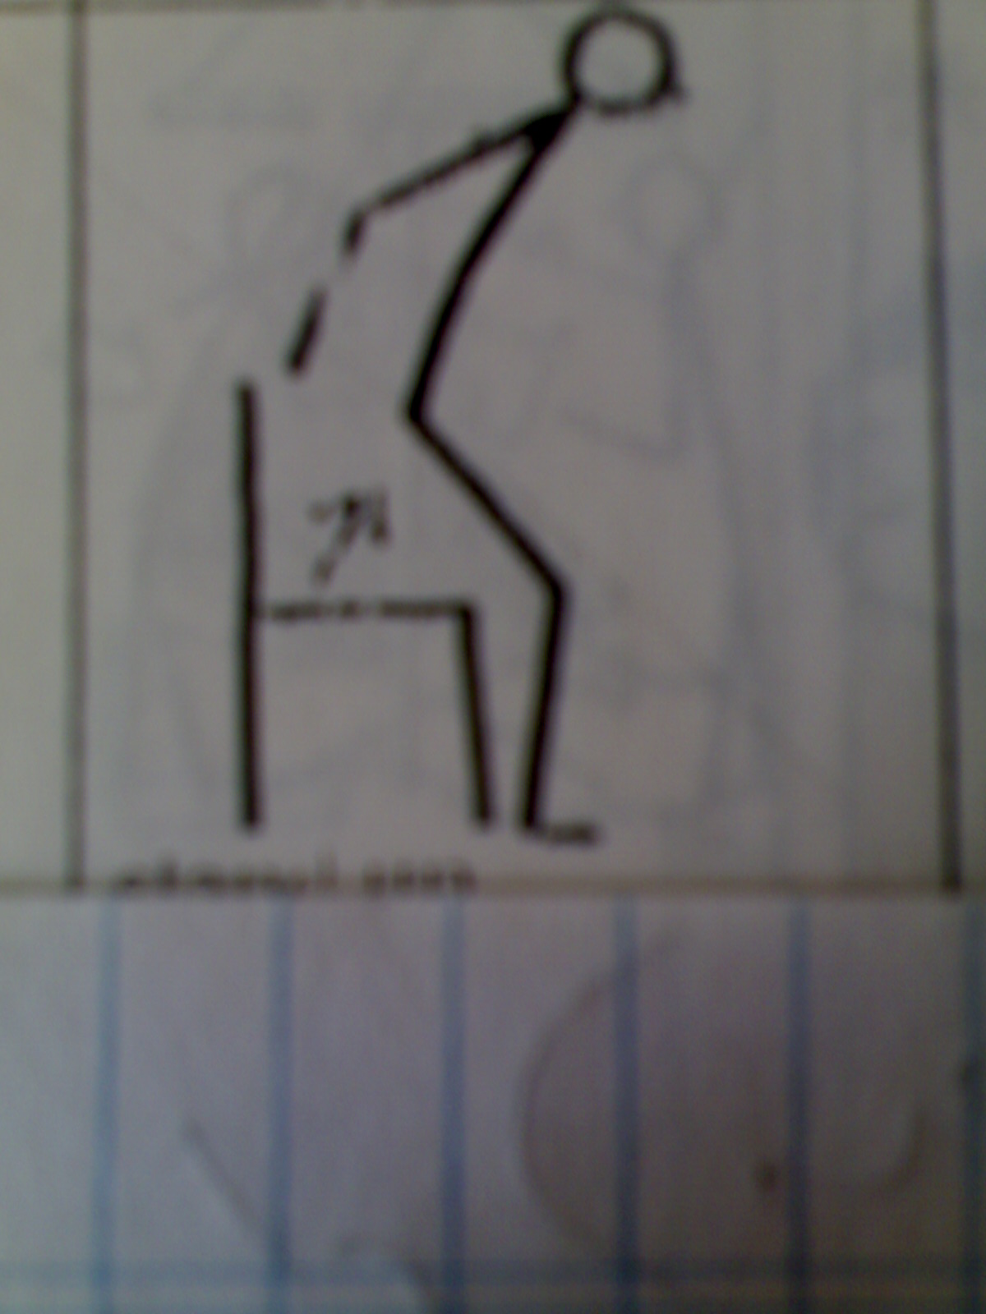  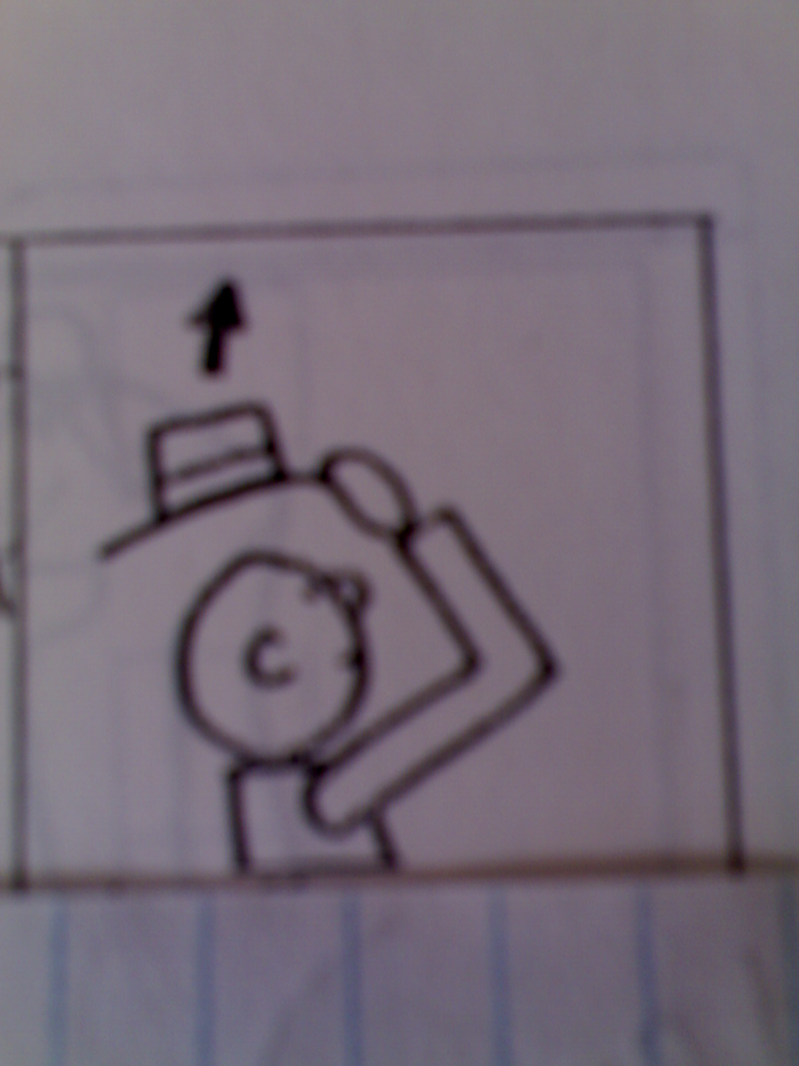  1 2  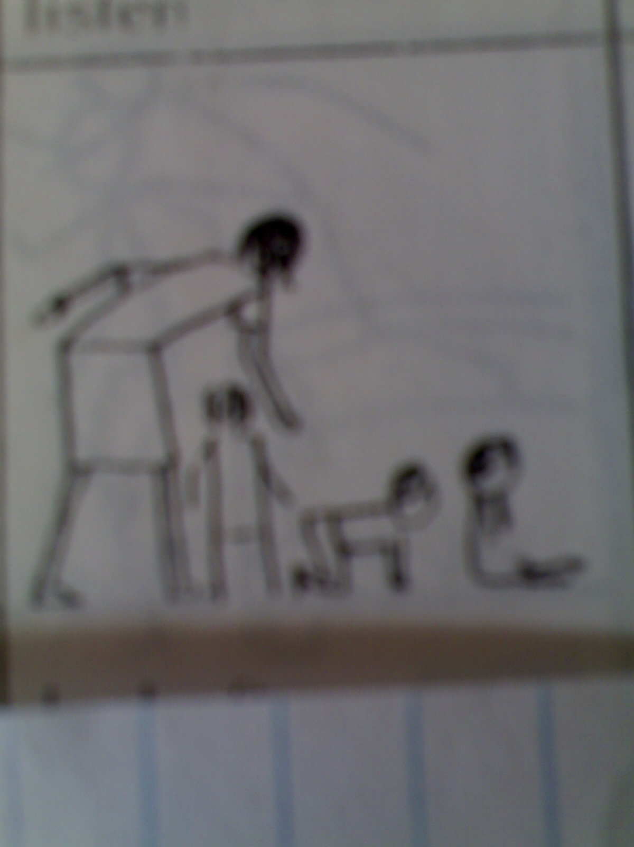  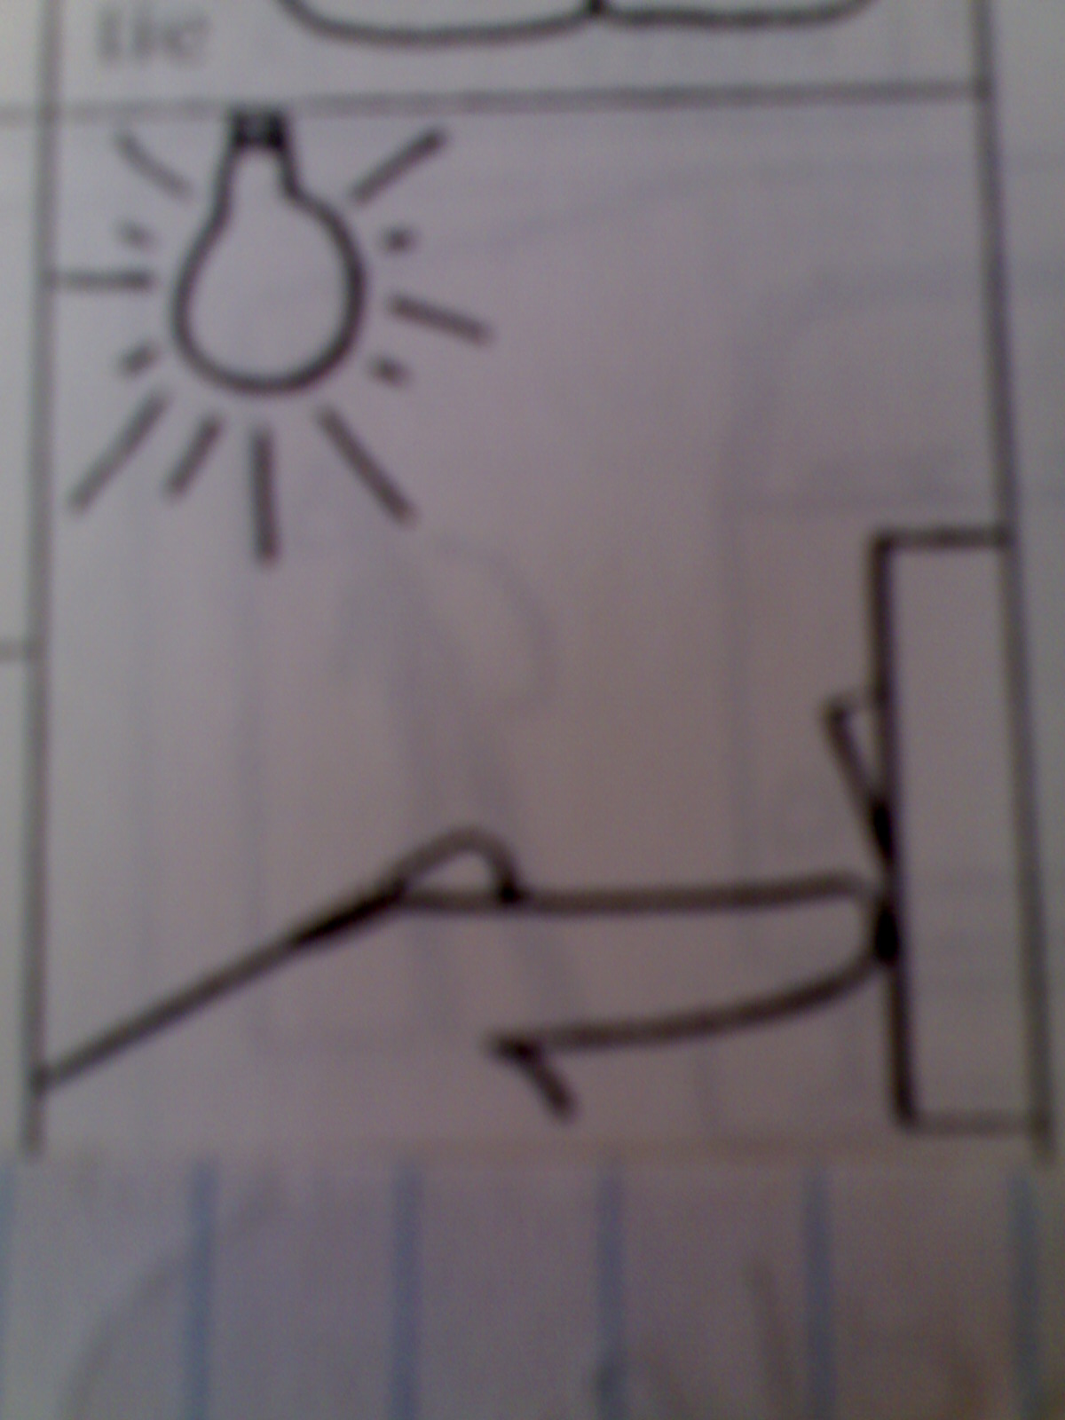  a. Look after b. Take off  c. Turn on d. Stand up  * Lead - in:  T: What do you call these words?  Sts: Phrasal verbs  T: What do you know about phrasal verbs?  Sts: ……………………………….  T: To know more about them, we come to grammar lesson of unit 14. | Look at the pictures and match  1. Turn on  2. Look after  3. Stand up  4. Take off  Answer the questions.
P  R  E  S  E  N  T  A  T  I  O  N  25mns | - Phrasal verbs  Ex: turn on  Adverb  Form: VERB + Particle Preposition  Guessing the meaning:  T gives some examples for sts to guess the meaning of the phrasal verbs  + He always gets up at 6 o’clock.  + Please take off your shoes before entering the room.  + Turn on the radio, please.  T supplies some other phrasal verbs:(using poster)  Get over: hồi phục  Go out: đi chơi , đi ra  Go away: đi khỏi  Go in: tham gia , đi vào  Go off : nổ, reo, vang lên  Go on: tiếp tục, xảy ra…  Fill in: điền vào  Give up: từ bỏ  Wash up: rửa chén…  Put on: mặc vào  Hurry up: nhanh chóng, nhanh chân  Lie down: nằm xuống  Sit down: ngồi xuống  Look up: tra cứu  Try out: thử  Hold up: trì hoãn, chặn đường, làm ngưng | Listen and copy
P  R  A  T  I  C  E  25mns | - Activity 1: Exercise 1: ( page 159)  Key: 2. fill in; 3. turn on; 4. take off; 5. wash up; 6. look up; 7. turn off; 8. fill in; 9. go on; 10 put on  - Activity 2: Exercise 2: ( page 160)  Key: 2. up; 3. out; 4. round; 5. on; 6. up; 7. down; 8. away; 9. down; 10. on  - Activity 3: Exercise 3: ( page 160)  Key: 2. look after; 3. takes after; 4. got over; 5. held up; 6. try out; 7. went off | Do exercises
P  R  O  D  U  C  T  I  O  N  10mns | - Fill in each of the blanks with a phrasal verb you have learnt. ( using handouts)  - I came late for class yesterday because my alarm clock didn’t ……………  - He studied French for three years and then …………. it …………..  - Please …………. the TV. I’m studying  - I can’t go out with you tonight because I must …………… my youngest sister.  Feedback:  - go off  - gave/ up  - turn off  4. look after | Do the exercise

The 4th 45-minute TEST Period: 93

UNIT 15: WOMEN IN SOCIETY Period: 94,95
READING

- Aims: by the end of the lesson, sts will be able to:
- read for specific information.
- know some information about women’s work.
- Method and teaching aids:
- mainly, communication approach.
- Pictures, textbooks, posters,
- Procedures.

Stages | Teacher’s activities | Students’ activities
W  A  R  M  E  R:  10 ms | WARM –UP:  Give some pictures of famous women:      1. Who are they?  2. In what field are they famous?  To understand more about the role of women in society we come to the reading | - Look at the pictures  - Answer the questions
P  R  E  -  R  E  A  D  I  N  G  30 ms | - Pre- teaching vocab.  - Deep-seated (adj) (translation)  Ex: deep-seated cultural beliefs  - To involve SO /ST in (doing) sth : to cause SO/sth to take part in or be concerned with sth  → involvement (n)  - Intellectual (adj) (explanation) connected with a person’s ability to think logically and to understand things  - to discriminate (v) (translation)  - advocate (v)  - Age of Enlightenment (n) (translation)  - Childbearing (n): giving birth to children (explanation)  - Check vocabulary (Rub- out and remember)  - T/F prediction.(poster)  1. Nowadays, women only do housework.  2. Women in most parts of the world have gained significant legal rights.  3. In the 18th, women could take part in social activities.  4. Today women have the right to vote. | Realize the words(meaning, pronunciation,stress)  Repeating, note- taking  Work in pairs
W  H  I  L  E  -  R  E  A  D  I  N  G  40  ms | - Checking T/F prediction  Ask Ss to read the text and check the statements true (T) or false (F)  - Task 1: Multiple choice  - Ask Ss to choose option (A, B, C or D) to answer the following questions  - Ask Ss to compare answers.  - Call on Ss to read their answers.  - Task 2: Identify the best title  - Asks Ss to read again the text and choose the best title for the text.  - Call on Ss to say what they choose and give explanation.  - Go over the answers with the class
P  O  S  T  -  R  E  A  D  I  N  G  10 ms | Women’s roles in society  Women in society  In the past  In the 18th century  As mothers  Political status  Suggested answer:  *In the past: -as mothers  - as wives  - childbearing  *In the 18th century:- social status  -political status  -economic status  *Nowadays:- equal work opportunities  - right to formal education  - pay to men  - right to vote

The 4th 45-minute TEST CORRECTION Period: 97

Unit15: WOMEN IN SOCIETY Period: 98
LANGUAGE FOCUS Không dạy phần Pronunciation

I. Aims: By the end of the lesson, SS will be able to
- know how to use the rising tune
- learn meaning of some phrasal verbs and how to use them
II. Methods and teaching aids: Integrated, mainly communicative / Textbooks, teacher’s books, paper poster
III. Procedure

Stages | Teacher’s activities | Students’ activities
W  A  R  M  E  R  5ms | - Play a game( lucky number)  -Divide class into 2 groups (A & B)  -Ask each group to take turns to choose a number, for each number there is a question for them to answer. If they get it right, they have 5 points. If they get a lucky number they also get 5 points without answering. The winner will be the group who gets more points.  LUCKY NUMBER  Questions  - Something that you put up when it is raining  - Lucky number  - Something that you should switch off before you leave the room  - Something that you can try on when you go into a shoes shop  - Lucky number  - Something that you should give up if you want your health better  - A type of food you should keep off if you’re on a diet  - Something that you should take off when you enter pagoda  - Lucky number  - Something that you take up if you want to get fit  - Phrasal verbs_ Ask sts to look at the Underlined Phrases and answer the question  - What are the parts of their speech?  Lead-in : today we will review the phrasal verbs  Game: Mime  Divide class into 2 groups A& B  Ask sts to look at teacher’s actions and write on board  Action 1: put on the hat  Action 2 : turn off the light  Action 3: sit down on the chair  Action 4: throw the pen away  Action 5: turn on the light  _ Ask s to look at the Underlined Phrases and answer the question  What are the parts of their speech?  Lead-in : today we will review the Phrasal verbs | -Divide into groups A& B  - Answer the questions  Keys  an umbrella  Lucky number  Lights  Shoes  Lucky number  Cigarette/wine  Cake/meat…  Hat  Lucky number  Sports  Phrasal verbs  Write down the words based on the actions
  1 | 2 | 3 | 4 | 5
  6 | 7 | 8 | 9 | 10
P  R  E  S  E  N  T  A  T  I  O  N  13mns | Eliciting:  - What should you do before you leave the room?  - Say this sentence in another way.  -What should you say when you replace the lights by a pronoun “them”?  _Ask Ss to focus on the sentences above to give the notes  Some phrasal verbs have an object.  + The particle can come before or after the object  + If the object is a pronoun, it must come before the particle.  *Elicit from the Ss to have sentences  She looked after her husband while he was ill.  She looked after him.  T: Can you put “her husband” or “him” before the particle “after”?  Ss: No.  Some phrasal verbs have an object, but the particle cannot move. | Expected answers  - I should turn off the lights  _I should turn the lights off  _ I should turn them off.
P  R  A  T  I  C  E  12ms | Activity 1 Multiple choice  1. You’re always asking me ____ money. Ask somebody else for a chance.  A. about B. for C. to D. over  2. I’ve applied ______ a job at the factory. I don’t know if I’ll get it.  A. to B. with C. for D. on  3. If I want a job at the factory, who do I apply ______?  A. after B. up C. from D. to  4. I’ve searched everywhere _____ John but I haven’t been able to find him.  A. for B. with C. to D. on  5. I don’t want to talk ______ what happened last night. Let’s forget it.  A. to B. with C. about D. over  6. I don’t want to discuss _____ what happened last night. Let’s forget it.  A. with B. ✓ C. on D. at  7. We had an interesting discussion ____ the problem but we didn’t reach a decision.  A. about B. for C. to D. over  8. Keith and Sonia are touring Europe. They’re in Rome at the moment, but tomorrow they leave ______ Venice.  A. about B. for C. ✓ D. on  9. The roof of the house is in very bad condition. I think we ought to do something _____ it.  A. to B. for C. ✓ D. off  10. We waited _____ Jim for half an hour but he never came.  A. about B. on C. for D. in  - Check and give feedback  Activity 2  1. I ______ my watch to see what the time was. (glance)  2. We’ve been ____ the party but unfortunately we can’t go. (invite)  3. Please ______ me! I’ve got something important to tell you. (listen)  4. Don’t ____ stones _____ the birds. That’s prohibited. (throw)  5. The women sitting opposite me on the train kept ____ me. (stare)  6. Sally and Kevin had an argument and now they’re not ____ one another. (speak)  7. I _____ Joanna last week but she hasn’t replied to my letter yet. (write)  8. Be careful with those scissors! Don’t ____ them ____ me. (point) | Work in pairs and choose the correct answer  Key  1.B  2.C  3.D  4.A  5.C  6.B  7.A  8.C  9.B  10.C  Work in pairs  Keys  1.glanced at  2. invited to  3. listen to  4. throw … at  5. staring at  6. speaking to  7. wrote to  8. point … at
P  R  O  D  U  C  T  I  O  N  8ms | Ask sts to rewrite the following sentences ,using the verbs in the brackets  1.We don’t have any milk.(run)  2.It took me a long time to recover from my illness(get)  3.Peter is just like his grandfather(takes)  4.I think we’ve found an answer to the problem.(come)  5.Ann is someone I really respect.(look) | Suggested answers  1.We have run out of milk.  2.It took me a long time to get over my illness  3.Peter takes after his grandfather .  4.I think we have come up with an answer to the problem.  5.Ann is someone is really look up to.

